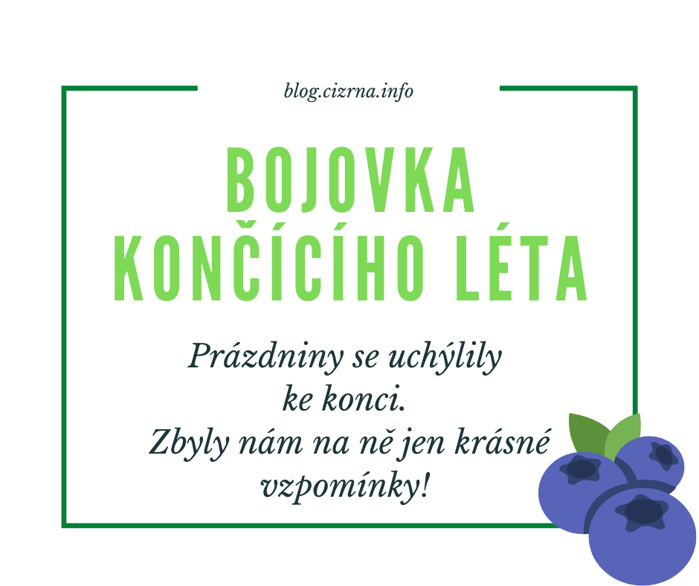

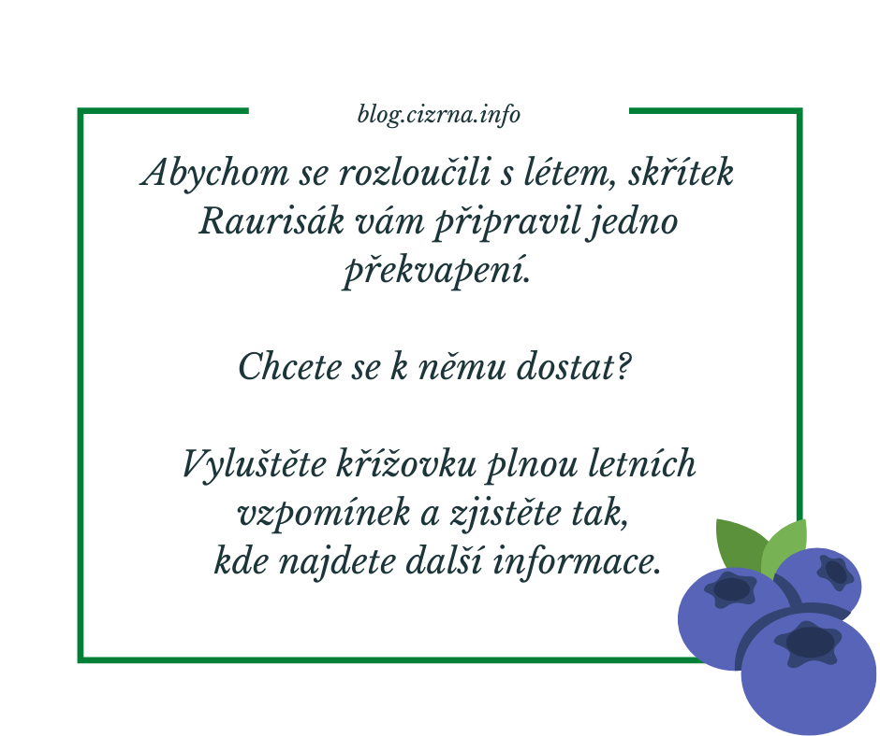

Vylušti křížovku a dozvíš se, kde je poklad!

|  |  |  |  |  |  |  |  |  |  |  |  |  |  |
| --- | --- | --- | --- | --- | --- | --- | --- | --- | --- | --- | --- | --- | --- |
|  |  |  |  |  |  |  | 1. |  |  |  |  |  |  |
|  |  | 2. |  |  |  |  |  |  |  |  |  |  |  |
|  |  |  |  |  | 3. |  |  |  |  |  |  |  |  |
|  |  |  |  |  |  | 4. |  |  |  |  |  |  |  |
|  |  |  |  | 5. |  |  |  |  |  |  |  |  |  |
|  |  | 6. |  |  |  |  |  |  |  |  |  |  |  |
|  |  |  |  |  |  |  | 7. |  |  |  |  |  |  |
| 8. |  |  |  |  |  |  |  |  |  |  |  |  |  |
|  |  |  |  |  |  |  | 9. | R |  |  |  |  |  |
|  |  |  | 10. |  |  |  |  |  |  |  |  |  |  |
|  |  |  |  |  |  |  | 11. | J |  |  |  |  |  |
|  |  |  |  | 12. |  |  |  |  |  |  |  |  |  |
|  |  | 13. |  |  |  |  |  |  |  |  |  |  |  |
|  | 14. |  |  |  |  |  |  |  |  |  |  |  |  |
|  |  |  | 15. |  |  |  |  |  |  |  |  |  |  |

1. slovo v křížovce:

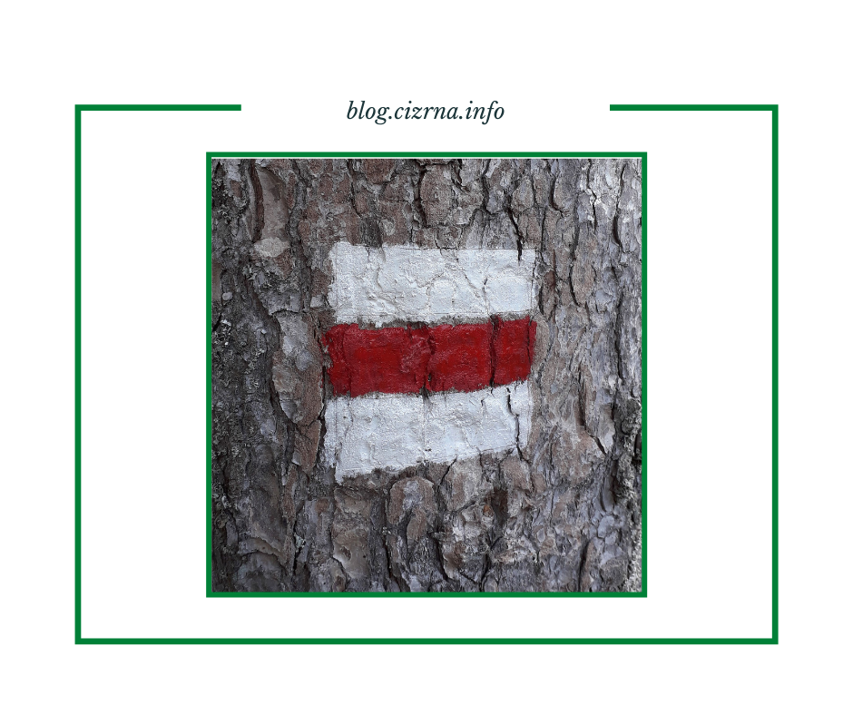

2. slovo v křížovce:

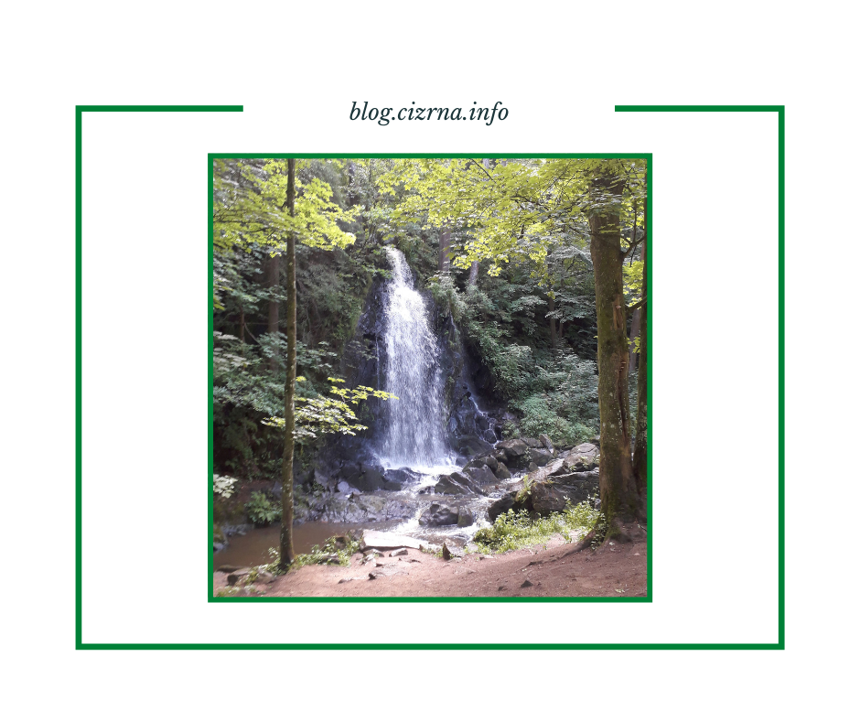

3. slovo v křížovce:

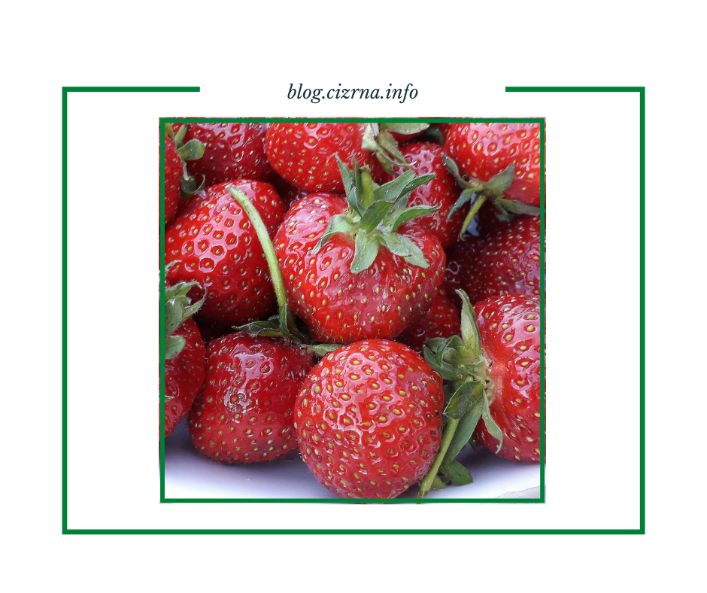

4. slovo v křížovce:

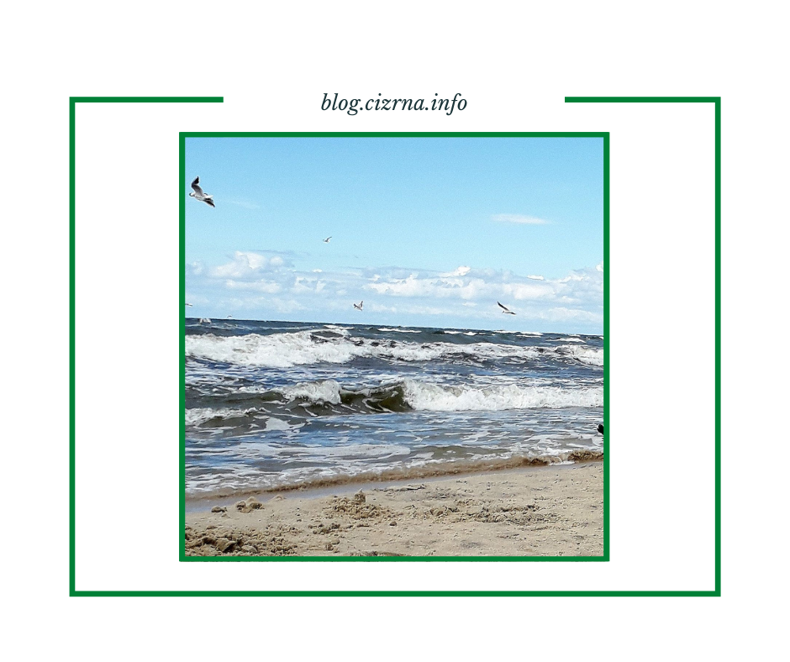

5. slovo v křížovce:

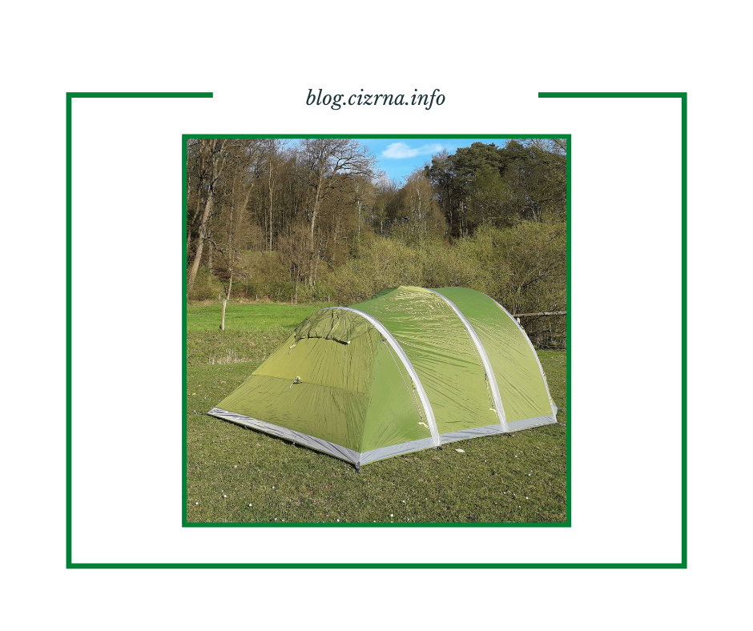

6. slovo v křížovce:

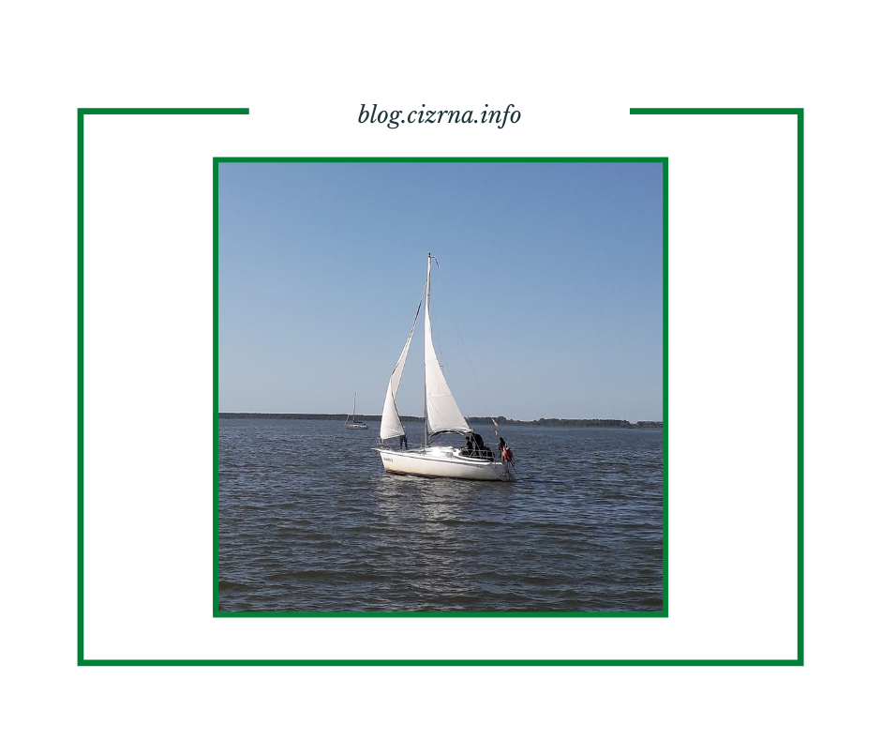

7. slovo v křížovce:

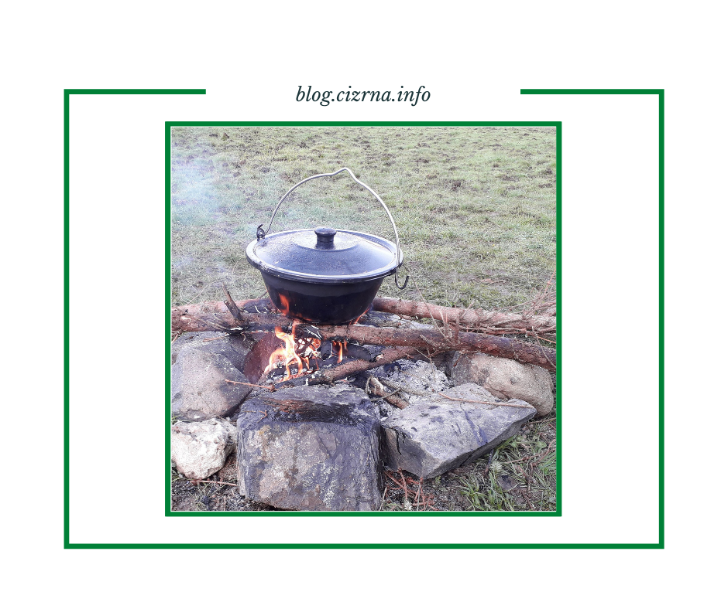

8. slovo v křížovce:

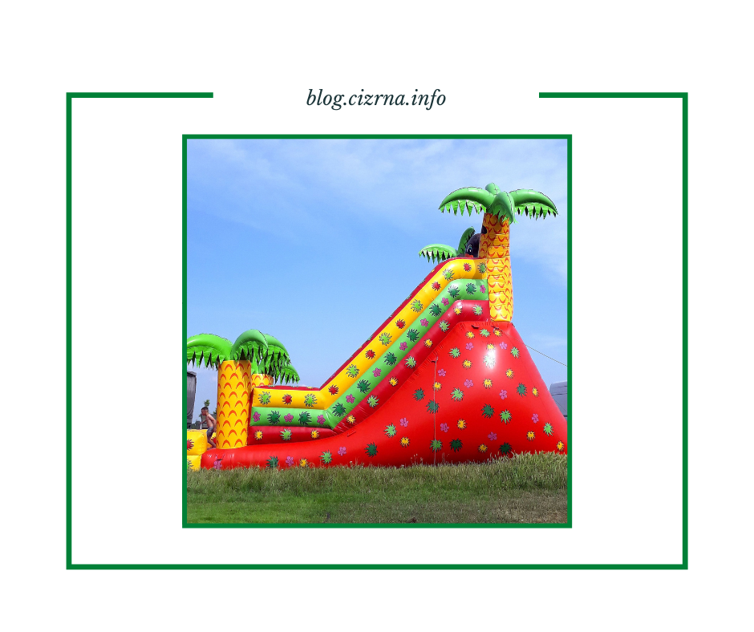

10. slovo v křížovce:

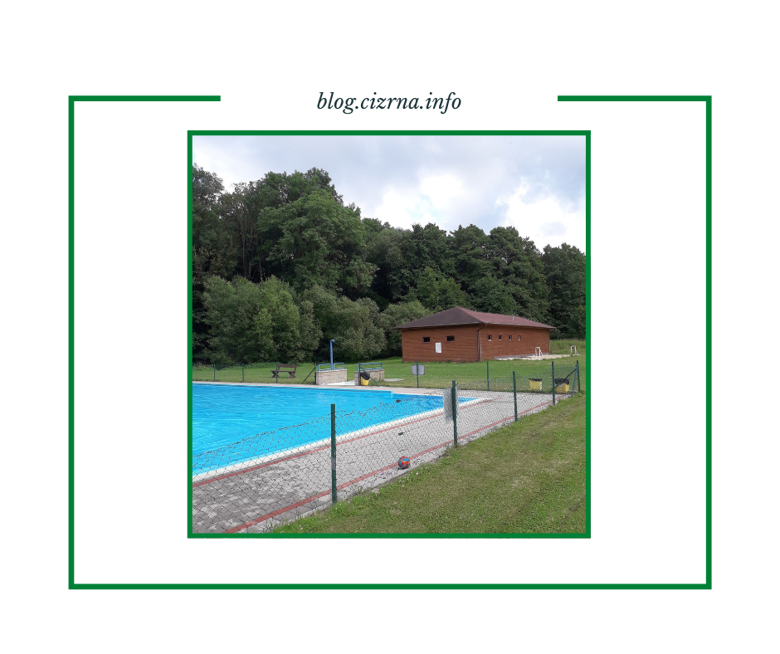

12. slovo v křížovce:

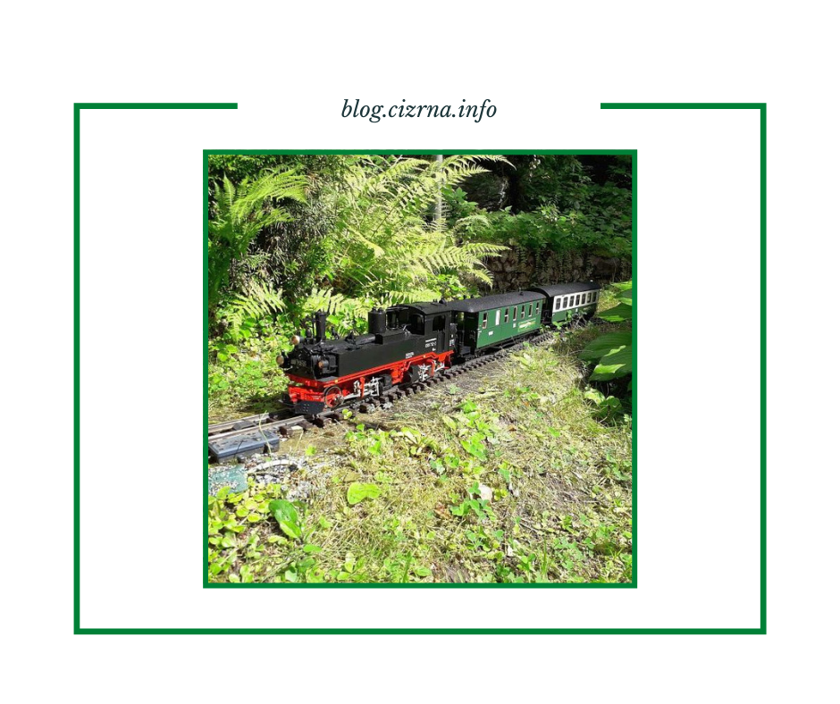

13. slovo v křížovce:

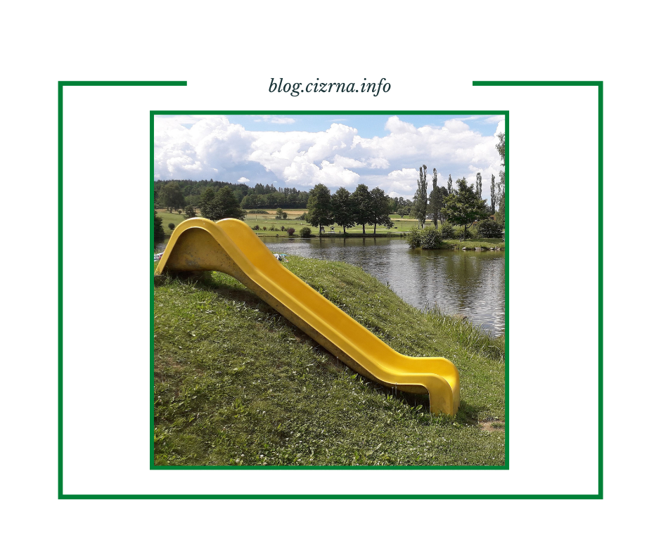

14. slovo v křížovce:

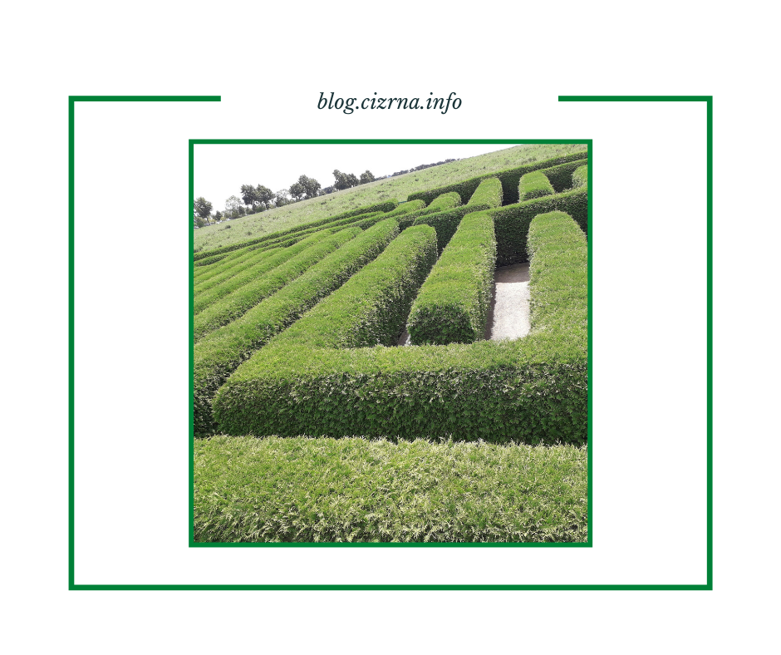

15. slovo v křížovce:

